***ENGINE CONTROL AND DATA ACQUISITION SYSTEM***

**User Manual**

# Contents

**Manual Reading Guidelines**

**Introduction**

**Overview**

**EDAC**

**Utilities**

**Editor**

**Logger**

**1. Start Project**

**EDAC Main Screen**

**2. Reset**

**Select Project**

**Begin Cycle/Click on Start**

**Start Engine**

**Stop the Engine**

**3. Check connection errors**

**4. Engine running status**

**Show online data**

**Show limit file**

**Show values**

**Show run status**

**5. Show Data Files**

**6. Manual-OP**

**7. Login -> Supervisor**

**8. Editor**

**Engine File**

**Limit File**

**Sequence File**

**Change Password**

**9. Project File**

**10. Login -> Service**

**11. System Parameters**

**Port Configuration**

**Default Limits**

**12. Input Output Configurations**

**Set Point 1 and Set Point 2**

**Channel Inputs**

**Module Inputs**

**Analog Inputs**

**Modbus Inputs**

Manual Reading Guidelines

This manual addresses engine testing engineers as well as operators. The instructions in this manual are given for their information and guidance. For effective reading of this manual some of the repeatedly used displays, operations, and conventions are explained in detail.

In this manual, you will find some text bold like Start, Stop. Note that all such type of text is from the corresponding dialog box/figure that is you will find this text as it is in the corresponding figures or it is part of the application’s front end.

Note is provided to give some important instructions related to the current topic. At some places reference to other sections are given for better understanding.

# Introduction

This application provides user friendly tool for creating auto cycles. These click, drag and drop tool provide user with facility of configuring cycle with individual step along with selection of which device parameters to be measured during which section of the step.

Also runtime behavior of each device can be controlled using this tool. It also provides user with program printing facility in PDF format for better visualization of the defined cycle and easy portability across company.

This application provides user with tremendous flexibility and ease of use in configuring the whole system and data acquisition hardware.

This application keeps user away from the complexities of integrating different devices of different makes and of different manufacturers working on different protocols. Best part of this application is, it requires zero programming knowledge to add/configure devices, cards, ports.

# Overview

## EDAC consists of following applications:

* Configuration
* Set point Calibration
* Programmer
* Software Main Screen
* Report

## Utilities:

* Log Viewer
* Alarm viewer
* Data Backup Manager
* This entire module can be accessed as single application .Logger is the main application used for test execution and test configuration.

## Editor:

Editor consists of Engine file, Limit File, Sequence File, Show File Format, and Change Password.

## Logger:

Logger is the main application used for test execution and test configuration.

# 1. Start Project

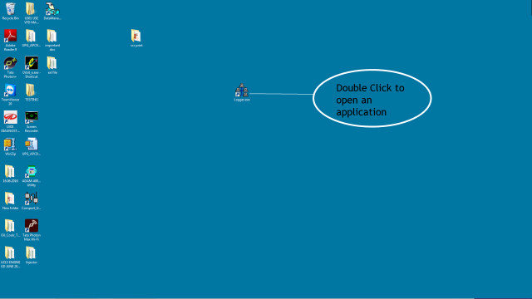

## EDAC Main Screen

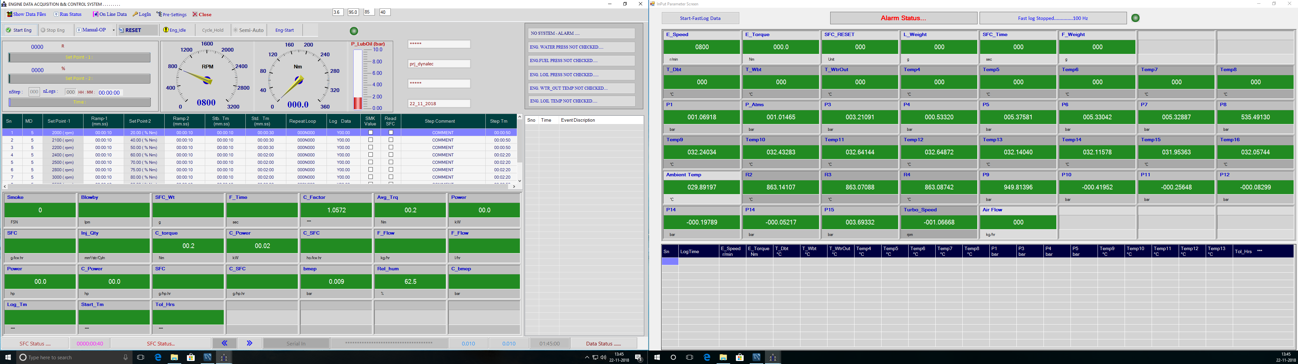

# 2. Reset

Select testing Parameters.

For filling data scan barcode.

First click on RESET button.

F

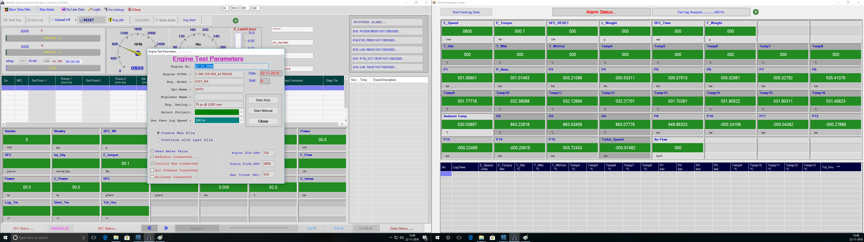

## 2.1 Select Project

F

3. Click on Start Auto.

1. Select project here.

F



## 2.2 Begin Cycle/Click on Start

F

Steps Loaded.

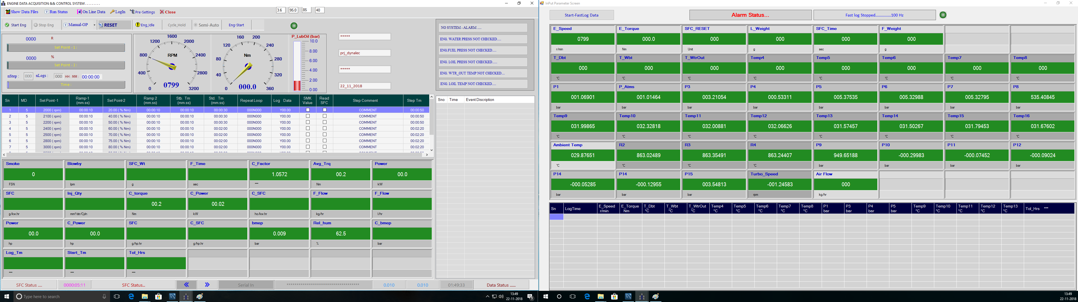

## 2.3 Start Engine by clicking on Start Eng. Button.

Click on Start Eng. After steps load

F



## 2.4 Stop the Engine

Click here to Stop the Engine.

F

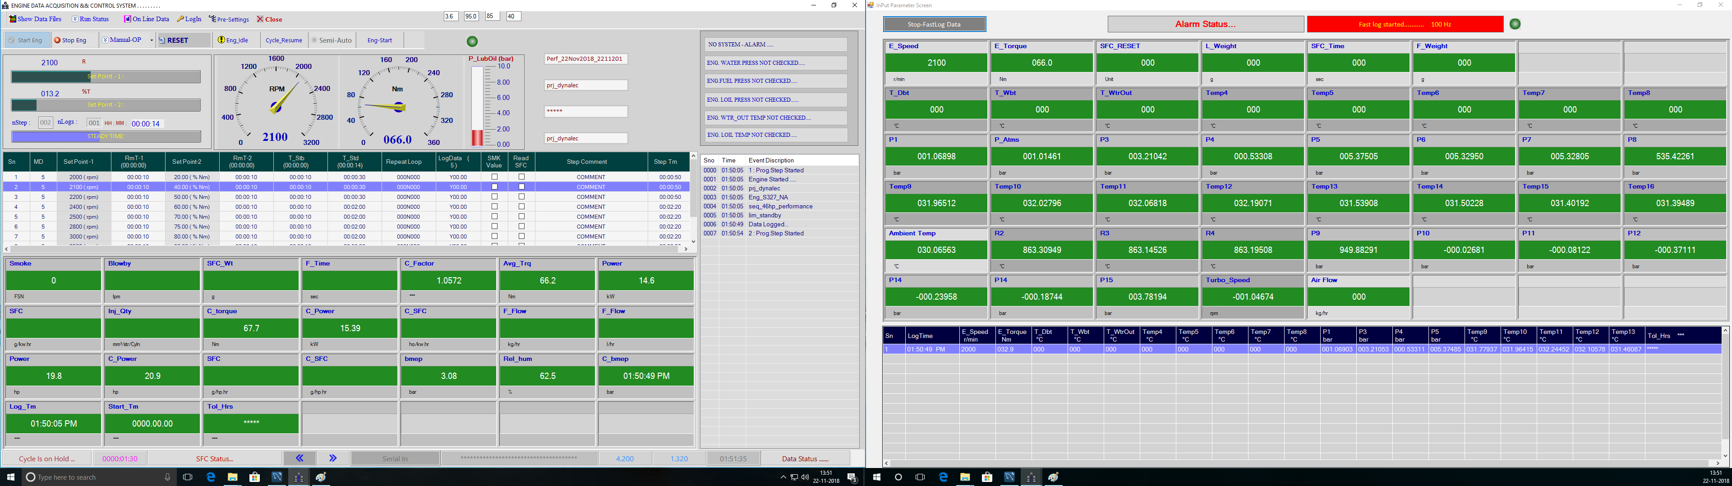

## 2.A Reset (Manual)

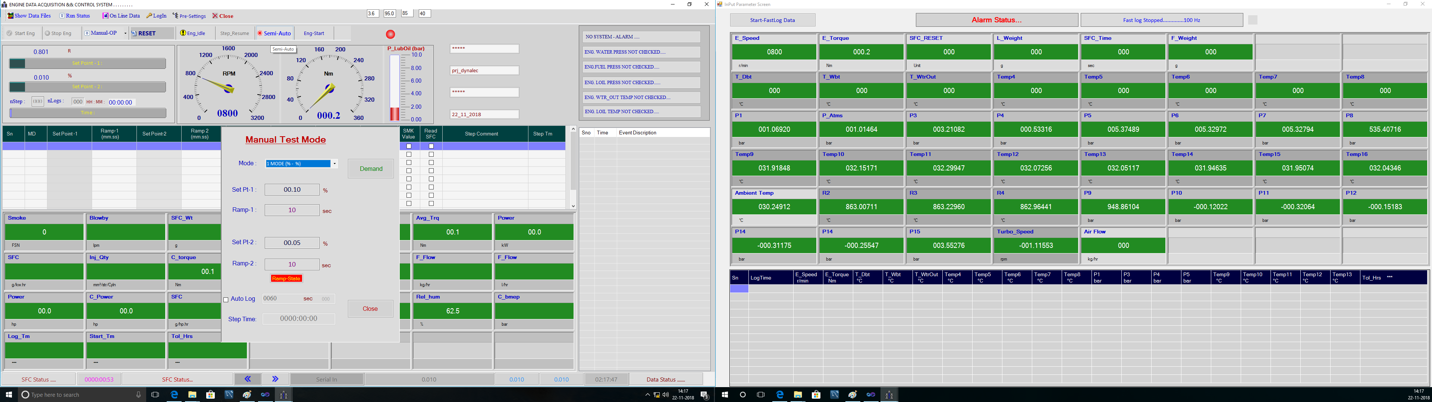

Enter values for set points and ramp time and click on Demand button.

# 3. Check connections and Errors

F

F

In case of this alarm check engine Fuel Pressure.

In case of this alarm check engine water Pressure



F

In case of this alarm check engine water out temperature.

In case of this alarm check engine lub oil Pressure.

F

# 4. Engine Running Status

F

Run Status dropdown menu.

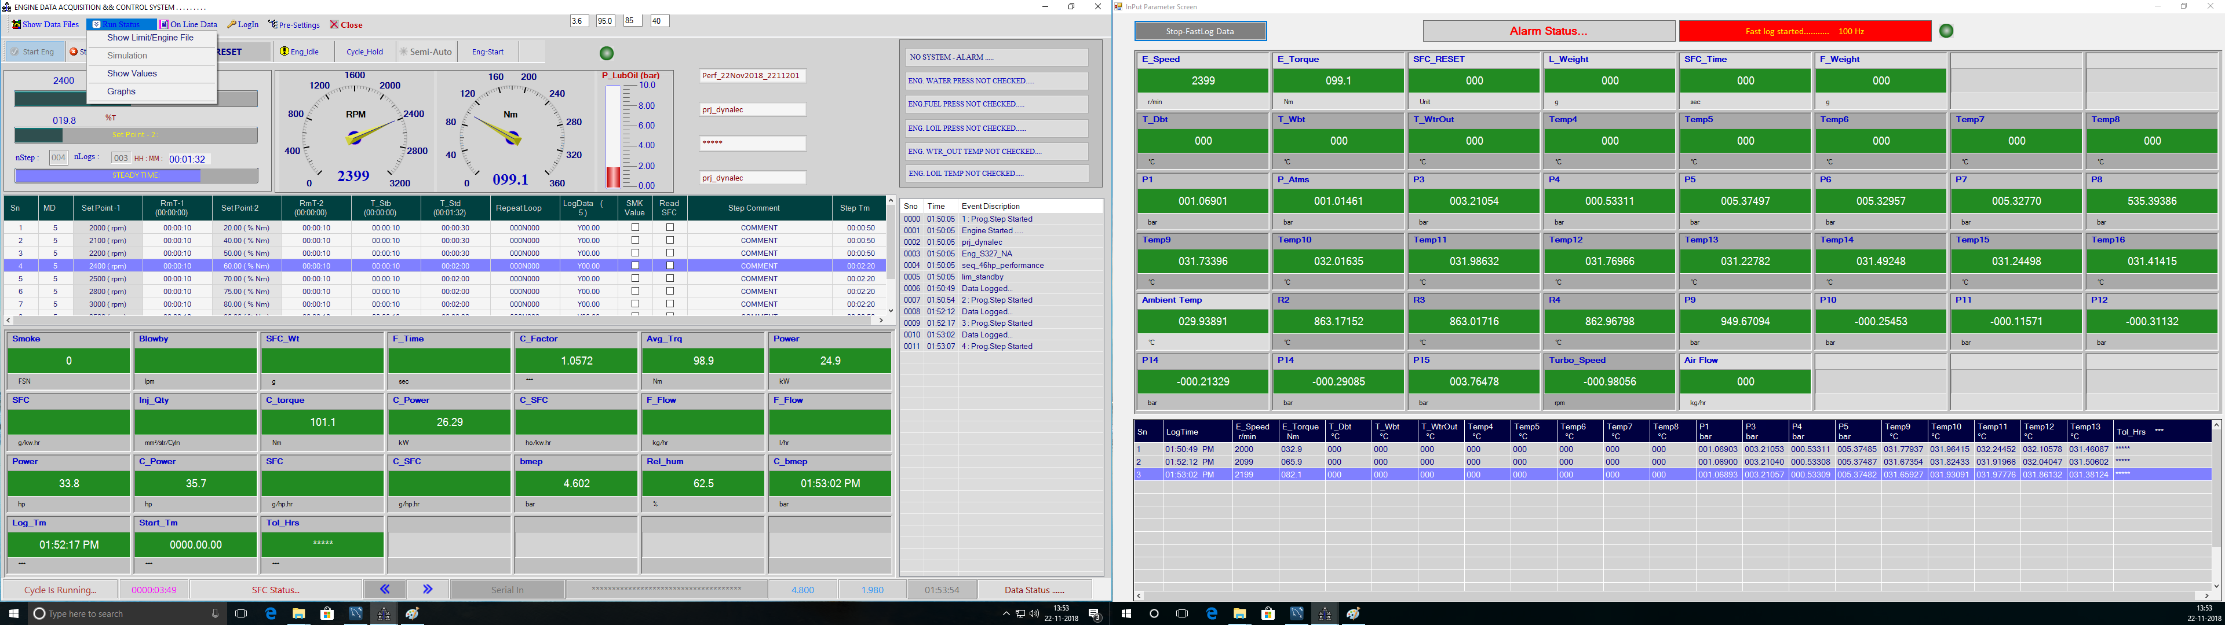

* Engine running status includes general saved data, PM data.

## Show Online Data

F

Shows saved data in this file.

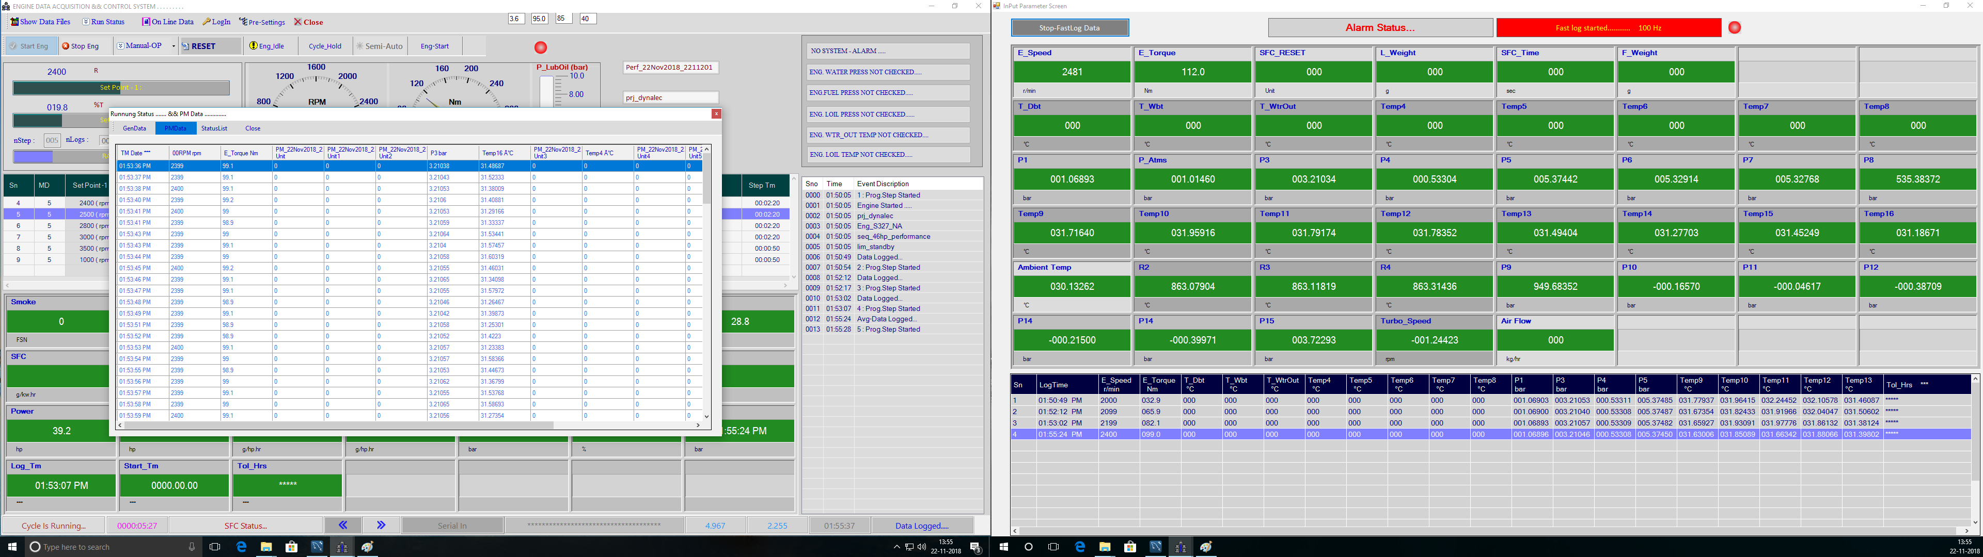

Show online data saves and displays saved data of current cycle.

## Show Limit File

Current limit file, engine file and sequence file shown here.

F

Run Status of Limit File, Engine File.

F

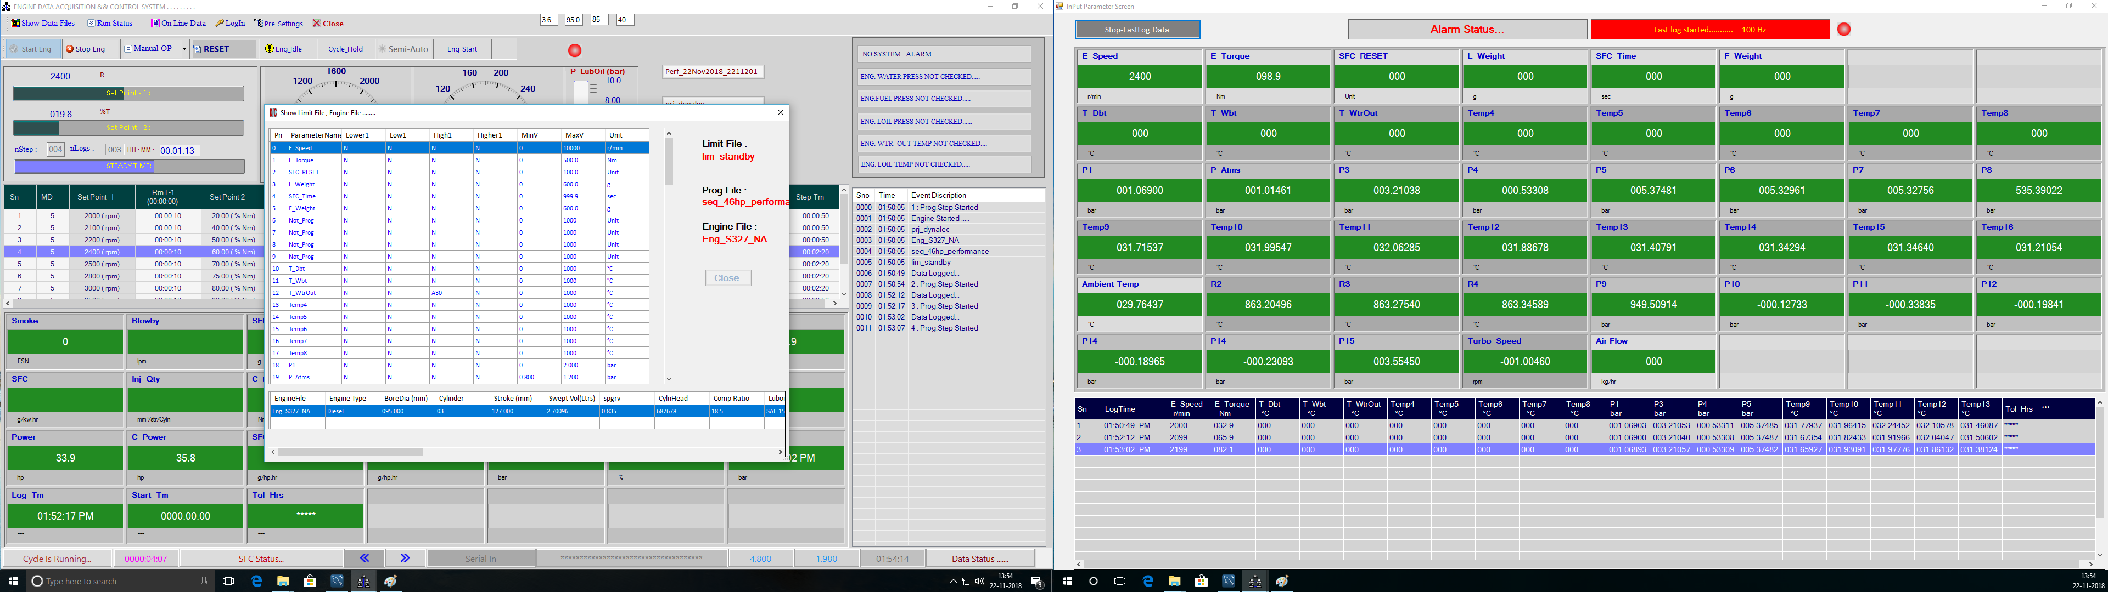

## Show Values

Values of all the input parameters are displayed here

F

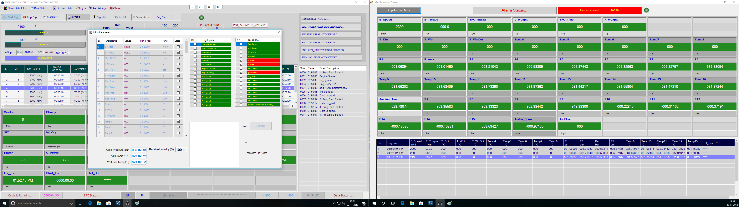

# 5. Show Data Files

Show Data Files -> Excel Formats -> Select File

Select month to open files of respective month.

F

Saved Data Files. Click on the file name to be open.

F

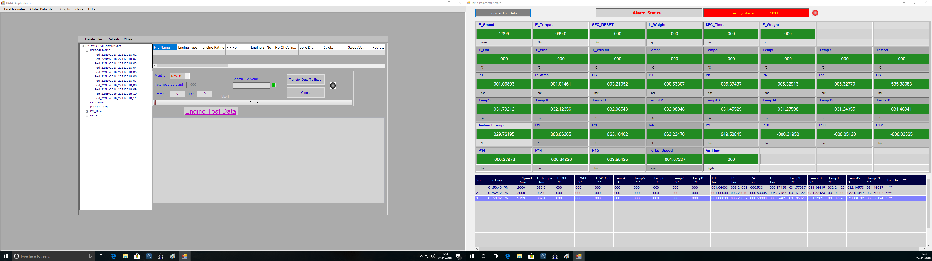

# 6. Manual-OP

Click on Manual-OP. This drop down menu will appear.

F

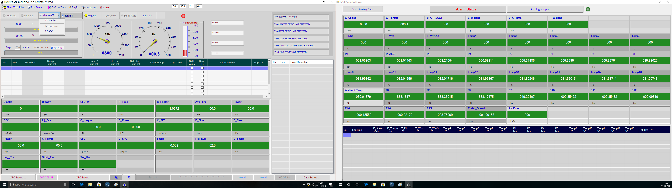

In Manual operation Manual smoke reading can be triggered, PID set points given, Limit, engine, sequence files can be viewed.

# 7. Login

## Login -> Supervisor

Click on Login Menu it will open login window. Select Supervisor as user name and enter password click on Ok to login as Supervisor for Port Configuration.

F

Click on Login to login as Supervisor.

s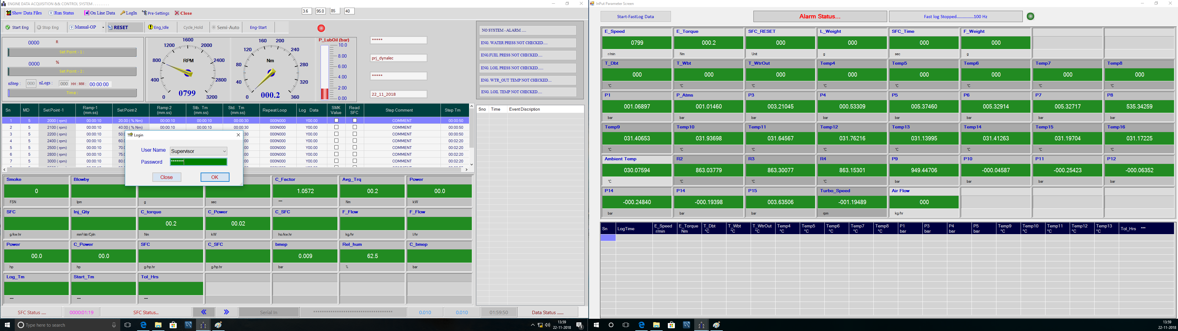

By login as a Supervisor Project and Editor will get enabled.

F

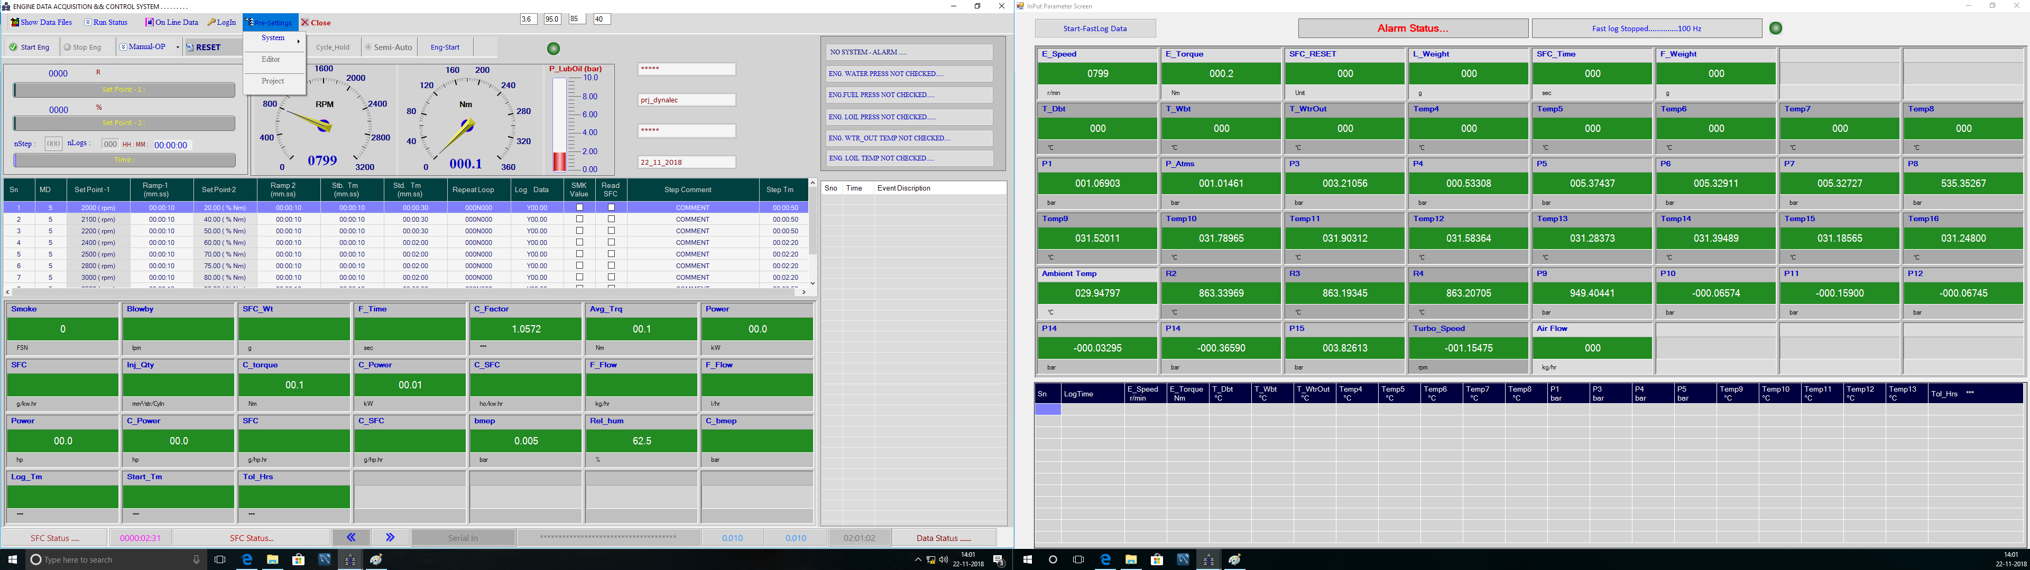

# Editor

F

Editors Window.

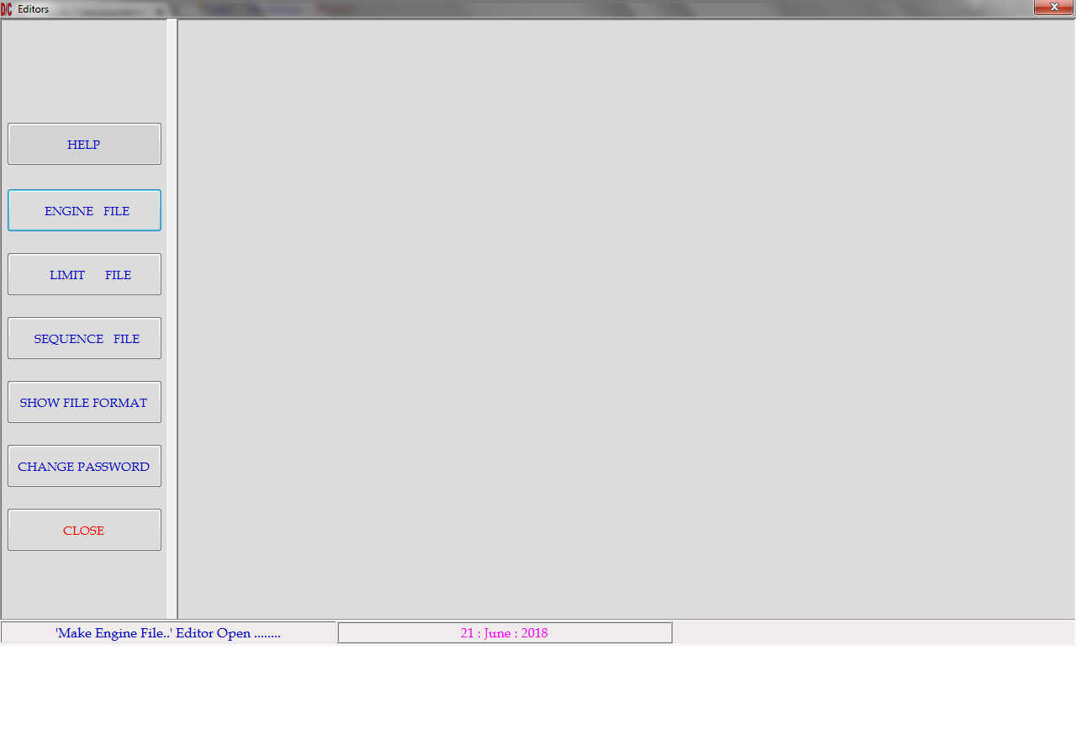

## Engine File

3. Save the file.

F

F

F

1. Click here to create a new engine file.

2. Type file name here.

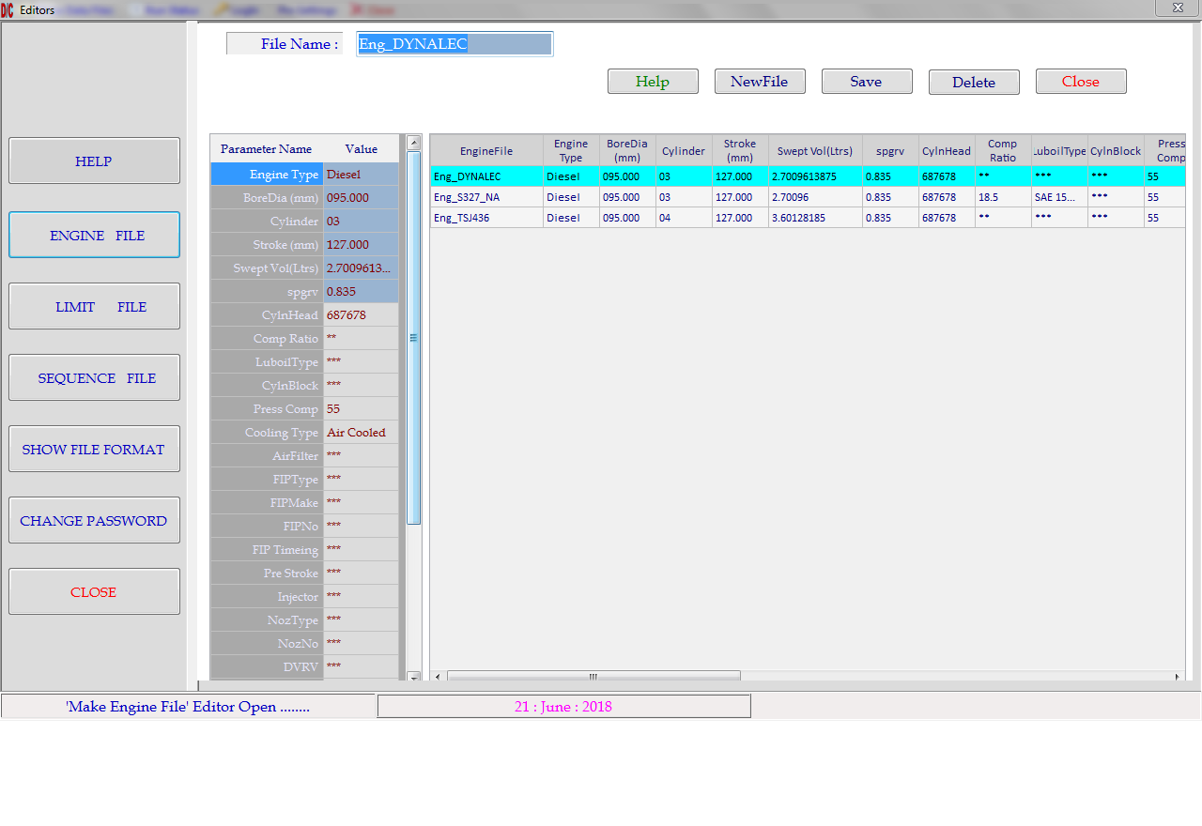

F

Previously created Engine file will display here.

F

4. Select file to be deleted and click on Delete button

1. Click here to create a new Sequence file.

F

F

2. Enter File Name here.

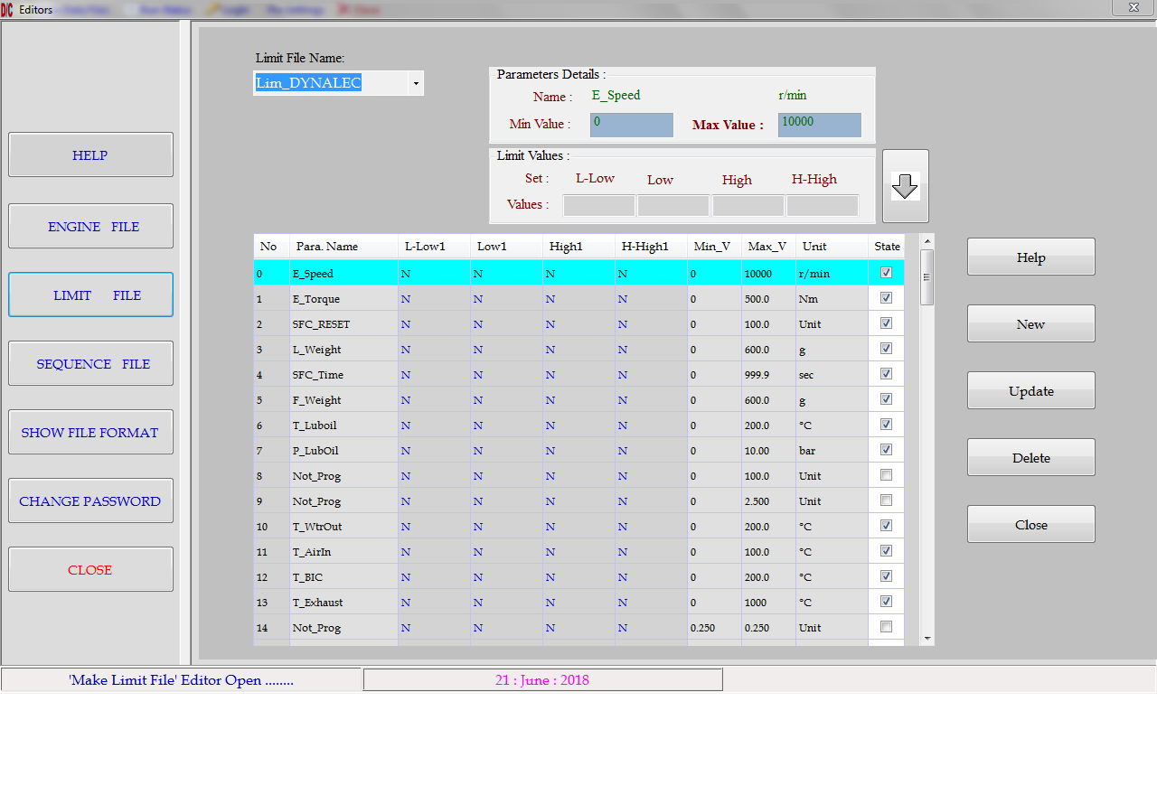

3. Click here to update a Sequence file.

F

F

Click here to add values.

## Limit File:

* Different limits for all analog channels and engine rpm can be set.
* Different limit files are created with different combinations.



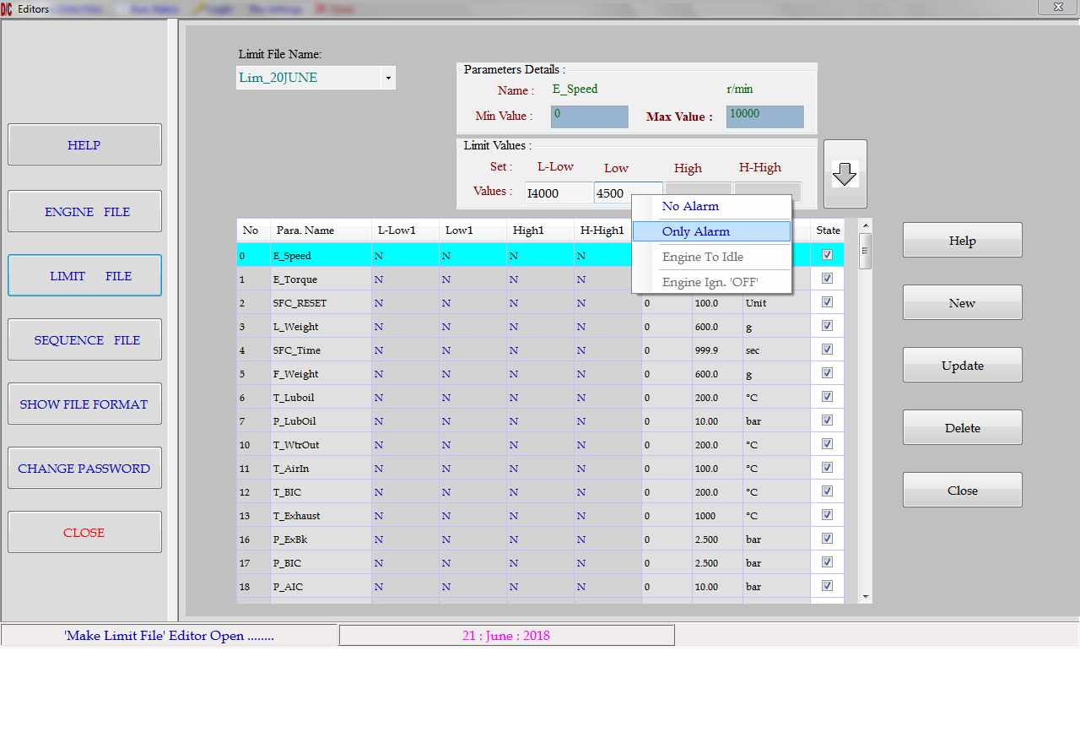

Alarm Status

F

**Alarm Status:**

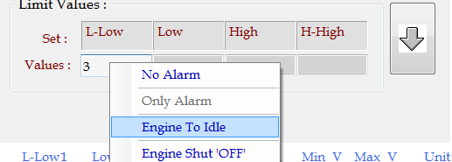

|  |  |
| --- | --- |
| NO Alarm | Limit values are considered to be Null. |
| Only Alarm | As limit crosses the particular channel will be highlighted on the screen. |
| Engine to Idle | As crossed the limit engine will be taken to idle rpm. |
| Engine Shut 'OFF’ | As crossed this limit engine will be stopped. |

## Sequence File

Select File name from here.

Steps of selected file

F

F

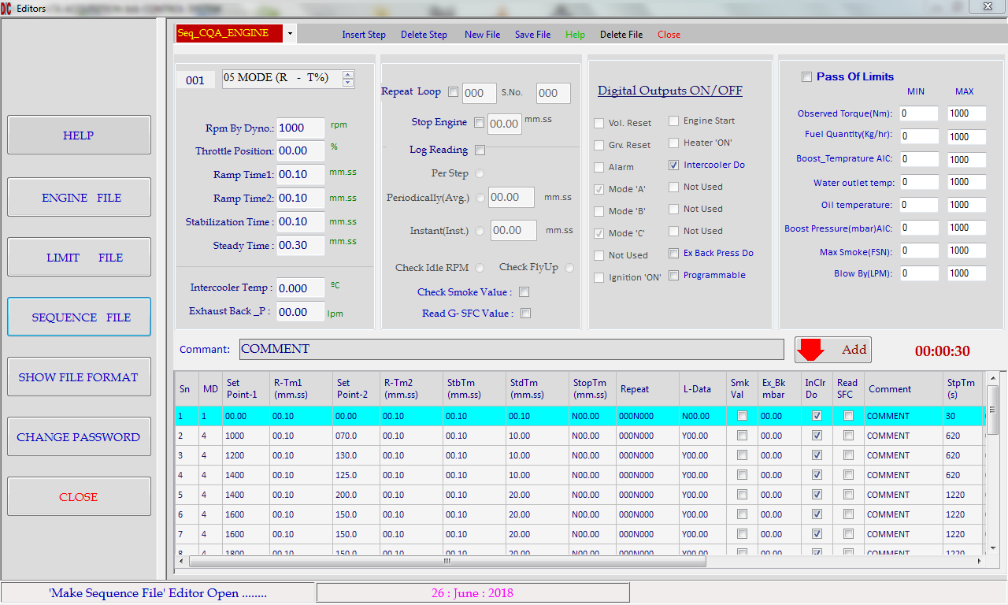

|  |  |
| --- | --- |
| Mode 1 :  Position / Position | Throttle is set at percent of set value (%) and Dynamometer current is set at percent of set value (%). This mode is used at the time of starting of engine   to prevent it from sudden loading or shutting up. So while editing the sequence program select mode '1' for first step. |
| Mode 2 :  RPM / Position | Engine RPM  is controlled at first set point by throttle lever position  controller and dynamometer current by (%) position of second set point. |
| Mode 3 :  Position/Torque: | Throttle is controlled at first set point in (%) and torque is controlled at second set point. |
| Mode 4 :  RPM/Load : | Engine RPM is controlled at first set point by throttle controller and Torque is controlled at second set point by Dynamometer controller. This mode is particularly used for part throttle engine performance. |
| Mode 5 :  RPM/Position : | Engine RPM is controlled at first set point by Dynamometer controller and Torque is controlled by throttle position controller at second set point (%). This particular mode is used for full throttle engine performance. |
| Mode 6 :  RPM/Load : | Engine RPM is controlled at first set point by Dynamometer controller and Torque is controlled at second set point by throttle position controller. This mode is used for full throttle performance or part throttle performance by selecting proper set points. |
| Ramp Time 1 | Switching time from one rpm value to another can be set here. It is in the form of mm:ss (max 99.59). |
| Ramp Time 2 | Switching time from one rpm value to another can be set here. It is in the form of mm:ss (max 99.59). |
| Stabilization time | The time duration which engine takes to reach set point |
| Steady Time: | Time for which engine will be having specified rpm value. It is in the form of mm:ss (max 99.59). |

**Log Reading**

Time interval for saving **'On Line Data'** of the engine can be set in logging option box. If Log Reading check box is not checked then data will not be saved for the particular step. If it is checked, following options will be enabled. Select one out of it.

Per Step: One reading per step.

Periodically: Data will be saved periodically with the time interval specified in the textbox. Format for the text box is (mm : ss).

**Repeat Loop**

* A group of steps can be repeated in loops by checking the **Repeat loop** check box. Starting step no. and no of loops textboxes will be enabled after checking the repeat loop check box. Set the starting step no. and no of loops (max 999). After completing the no of loops program will come out of the loop.

**Stop Engine**

* During the test run if it necessary to stop the engine for a short period, this option is used for the particular step. If **check box** is checked then text box will be enabled, enter the **'Engine off**' timing in the form of (MM:SS) so that, after completion of the particular step engine ignition will get off and engine will be stopped for entered time. As soon as time period get over engine will start automatically and data logging & controlling will start.
* This parameter is used for **Endurance testing**.

**Command Buttons**

|  |  |
| --- | --- |
| Help | On line help is available. |
| New | Creates a new file. |
| Add | Add all block values in the selected Preview List step. |
| Insert | Selected step is copied just below the selected step. |
| Delete Step | Selected step is removed from 'Preview List' box. |
| Save | All programmed steps are saved with the same file name. |
| Close | Program is saved and terminated. |
| Delete File | Selected File is Permanently Deleted. |

* After adding all the necessary parameters in the respective fields, click the '**ADD**' button to save field values.

## Show File Format

F

Select File format

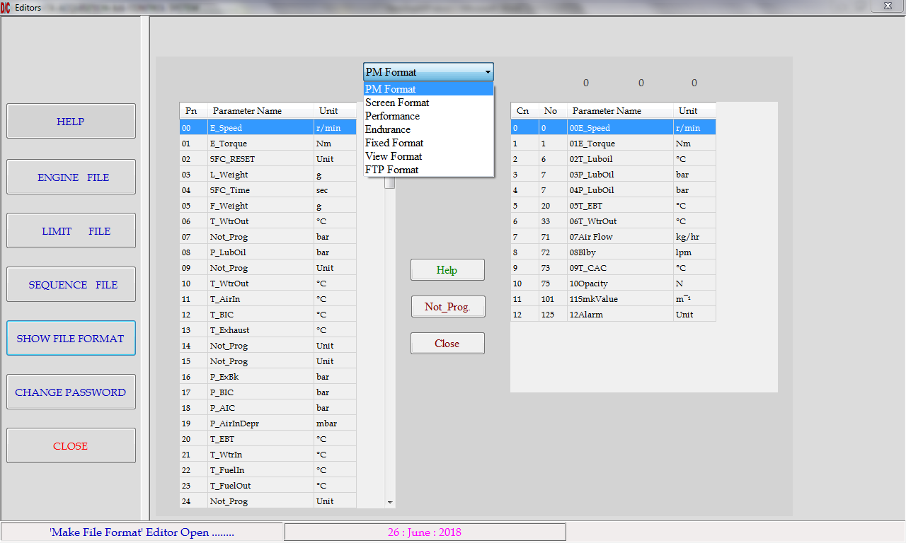

**PM Format:**

While running engine 13 analog channels can be monitor for every second and data is stored in the form of excel sheet. This data is available for 120 seconds. After 120th second 1st second data will be lost and file will be scrolled up and updated. If engine gets suddenly shut off due to any alarm, or any sudden break down by any inherent reason, then data of 120 secs before engine gets shut off is available and data of 60 secs after engine shut off is available for breakdown analysis.

**How to make Post Mortem format:**

* Select option “PM Format” from the combo box.
* Select parameter name from Left side table which is desired at col. No. 1 in PM Data file.
* Select the channel and click to the **channel**. Desired location in Configuration table (Right side table). Same channel no & parameter name will appear at the respective location. Repeat the same process for all 13 required channels.

**Command Buttons:**

|  |  |
| --- | --- |
| Help | On line help is available. |
| Not_Prog. | To Set Parameter Name as Not Program. |
| Close | Program will be terminated without saving. |

**Screen Format:**

While running the engine we can see only 39 channels at a time on screen. If the system is configured with analog channels more then 39, then it is necessary to give priority to important analog channels to display on screen in first 39 channels. So it is necessary to split these 42 channels in to two groups each of 39 parameters. This editor helps to split these parameters in to two groups. Arrange the sequence of these parameters in each group as per requirement. Some important channels can be displayed in both the groups such as engine torque, water outlet temperature, Lube oil pressure etc.

**Fixed Format:**

* While running the engine, all data of analog channels and calculated parameters is stored to the 'GEN' file in the excel format. Columns for this file are more than 65. Some unimportant data is also stored in this file. So this file becomes too large for printing and recording.
* Print result format stores only pre-selected 20 columns in the file.

**How to make Print Result format:**

* Select option “Fixed Format” from the combo box.
* Select parameter name from Left side table which is desired at col. No. 1 in result file.
* Select the channel and click to the **channel**. Desired location in Configuration table (Right side table). Same channel no & parameter name will appear at the respective location. Repeat the same process for all 20 required channels.

## Change Password

Password of Supervisor and Service can be changed here

F

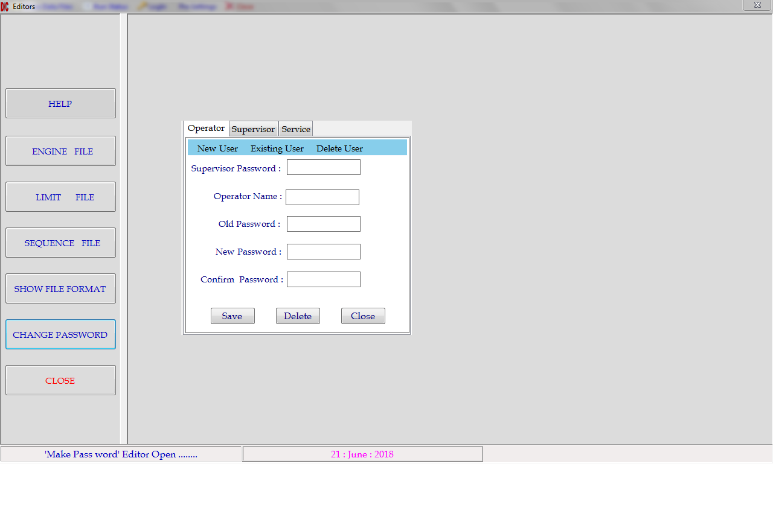

**Change Password:**

Change Password🡪 Supervisor

If Supervisor wants to change the password then enter old password and set new password click on save button.

Change Password🡪 Service

If you want to change service password then enter old password and set new password and click on save button.

# Project File

F

1. Click on New.

2. Enter File Name here

F

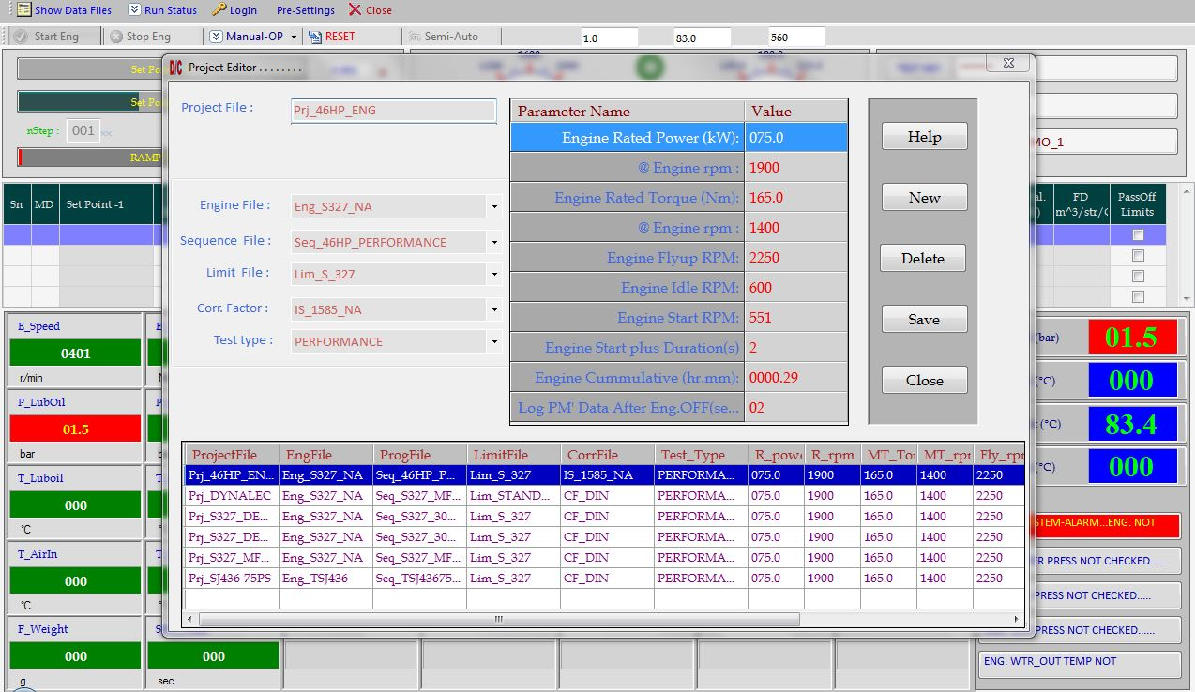

4. Save the Project File.

F

F

3. Select Files for Project File.

**Pre-settings 🡪 Project 🡪 Project Editor**

* If new project file opens then above screen “Engine Test Time Parameters” will open with all blank options.
* Fill all the options required. All fields should be filled with proper values. In all combo boxes select respective existing files, if required file is not available then come out of the screen and edit the required file and reopen the “Engine Test Time Parameters” file.
* Don't keep any field blank, otherwise file will not be saved.

|  |  |
| --- | --- |
| Help | While editing the values, if any help is required. |
| New | To create the new project file. |
| Delete | To Delete the project file. |
| Save | Save the current setting to the project file. |
| Close | Program will exit without saving the current settings. |

# Login

## Login -> Service

## System Parameters:

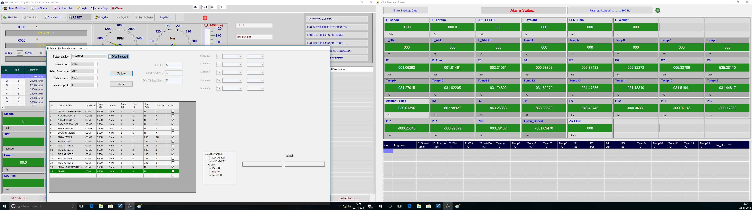

### Port Configuration:

Here you can configure the system parameters, which is called as “Port Configuration”.

* Login 🡪 Supervisor Login 🡪 System 🡪 System Parameter 🡪 Port Configuration
* Then you have to specify address COM Port no. for the PID.
* Specify the com port for Modbus.
* Specify the type of smoke meter and port used for it.

**Command buttons:**

**Update:**  After all changes made click on save button it will save all your changes.

**Close:** Program gets terminated after saving values of parameters.

### Parameter Configuration:

System Configuration allows to set default limit of system parameters which are presently connected like ADD on Cards, RPM, and Torque etc.

Login 🡪 Service 🡪 System 🡪 System Parameter 🡪 Para.Config.

1. Select the no. of “PCI 1716 ADD On Card/s” which is connected to your PC.

2. Enter Max Torque 237Nm.

3. Enter Max rpm 5000 RPM.

4. Enter Dyno constant 9550

5. Enter Test Cell no. 2

8. Enter First Shift Start time 6:30.

9. Enter Max rpm to meter 4700.

10. Enter Max torque to meter 450.

11. Rpm correction ‘On’- If it is **on,** and then rpm variation at the run time is set to the specified value

All above values are set according to Engine Configuration.

After all changes made click on save button it will save all your changes.

F

Click on Update after parameters configured.

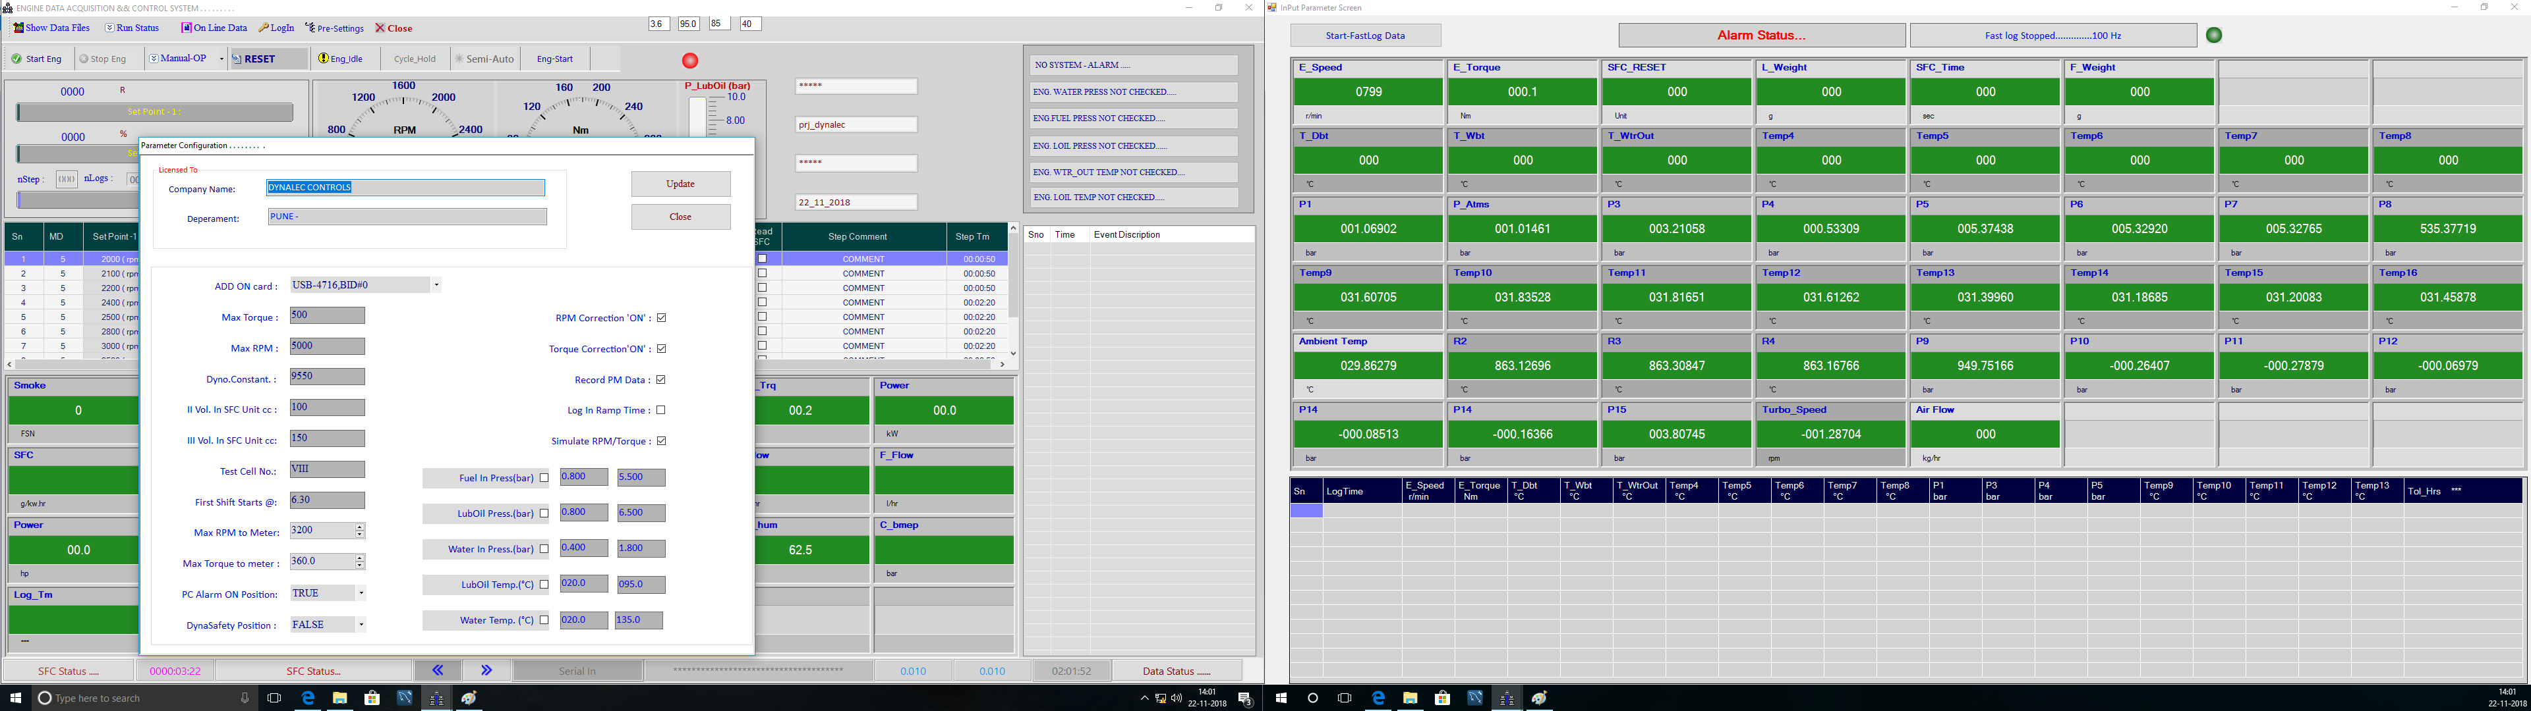

Clicking on default limits this window will open.

### Input Output Configurations

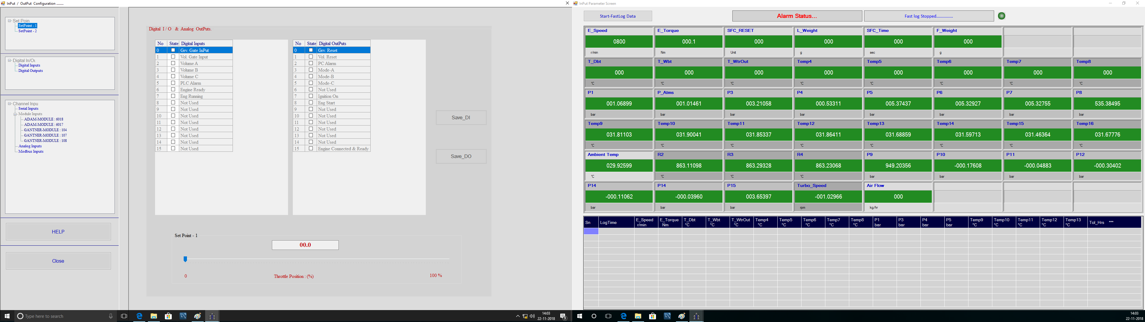

#### Set Point1 and set point 2:

* Here Analog Outputs are tested by giving values through software.
* If Analog Output I is varied from 0 to 10 v, then throttle should vary from 0 to 100%. E.g. If analog output I is set to 2 v, then Throttle should be 20%.
* If Analog output II is varied from 0 to 10 v, then dynamometer current should vary from 0 to 6 A. E.g. If Analog outputs II is set to 2v, and then dynamometer current should be 1.2A.

#### Channel Inputs:

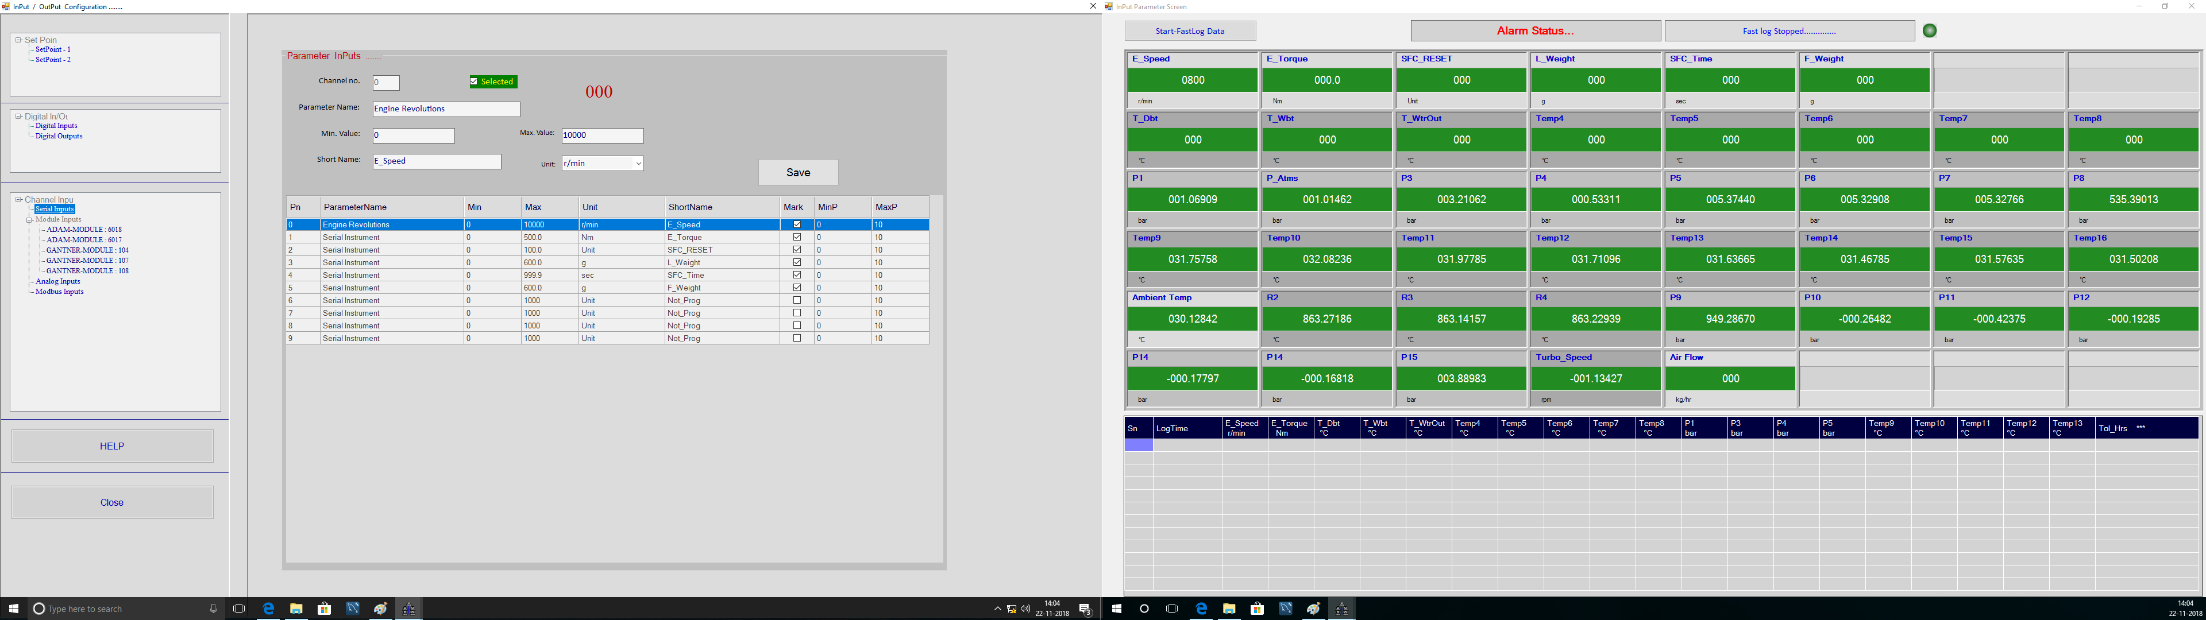

#### Module Inputs

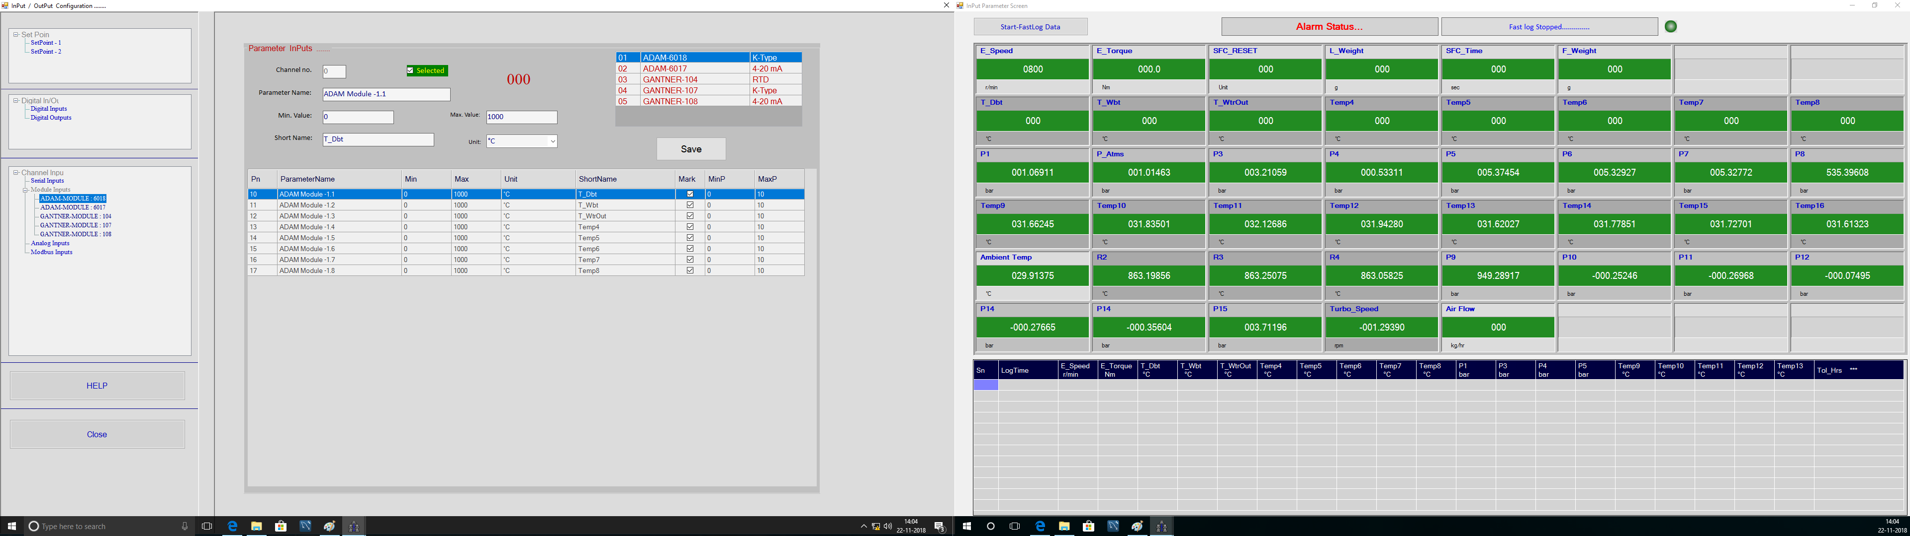

#### Analog Inputs

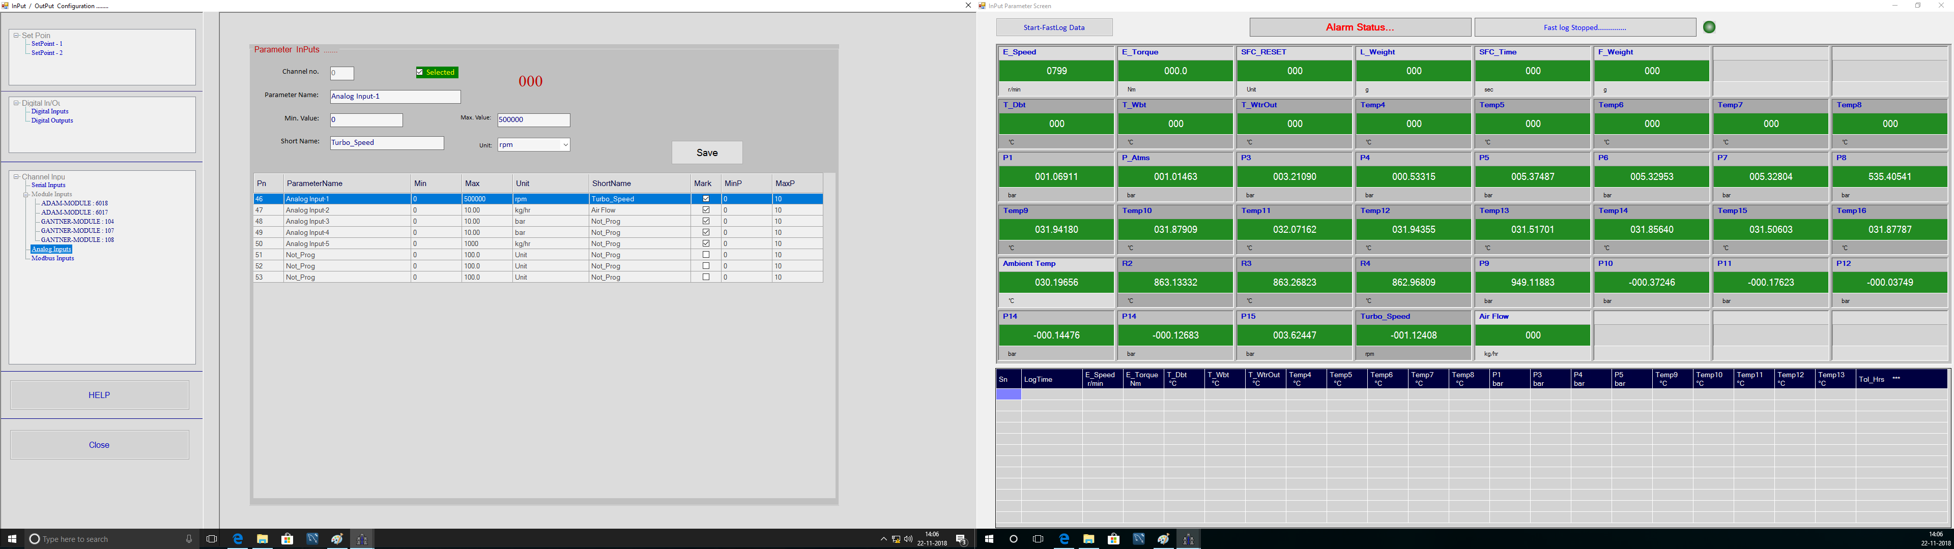

#### Gantner Inputs

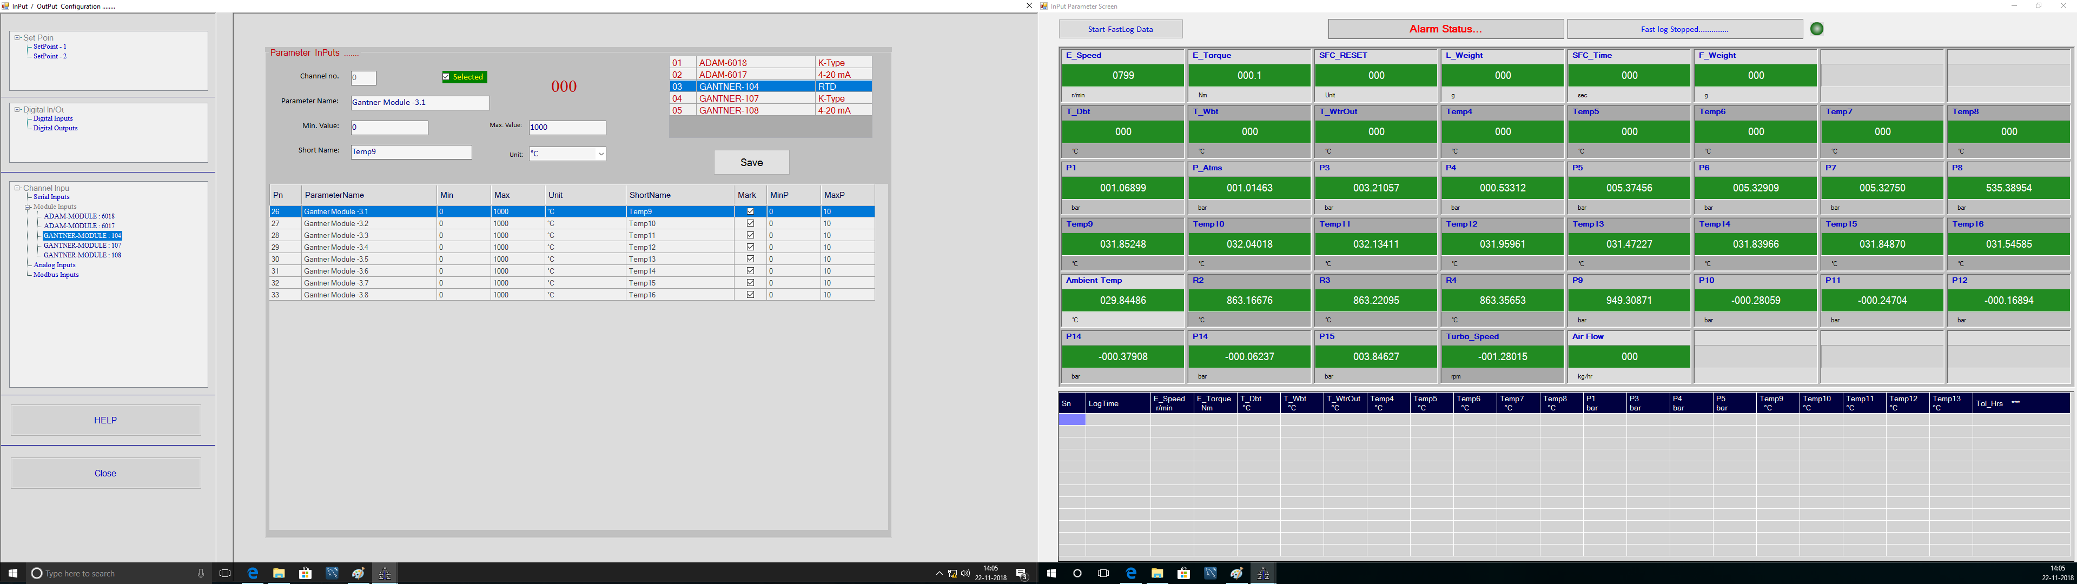

Current file name

F

F

F

Project File name.

Engine Number.

